**AC Current Measurement using Current Transformer and Arduino**

**Published**  April 21, 2020  3

[](https://circuitdigest.com/electronic-circuits/ac-current-measurement-circuit-using-current-transformer-and-arduino)

[Debashis Das](https://circuitdigest.com/users/debashis-das)  
Author

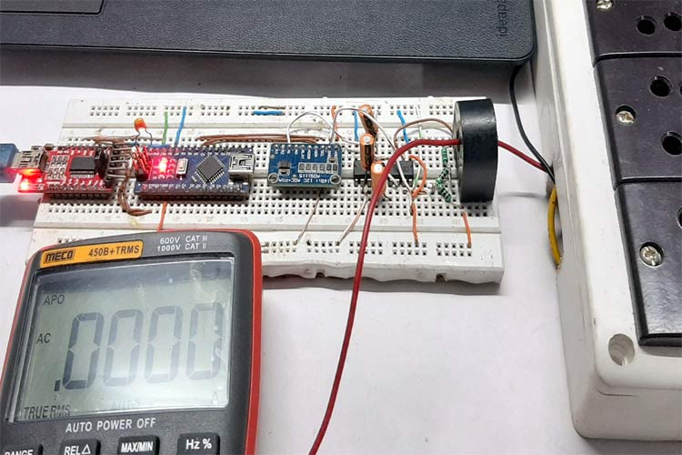

AC Current Measurement using Current Transformer and Arduino

A current transformer is a type of instrumental transformer specially designed to transform alternating current in its secondary winding, and the amount of current produced is directly proportional to the current in the primary winding. This type of current transformer is designed to non-invisibly measure current from the high voltage subsystem or where a high amount of current is flowing through the system. A current transformer's job is to convert the high amount of current to a lower amount of current which can be easily measured by a microcontroller or an Analog meter. We previously explained current measurement using the current transformer in different [types of current sensing techniques](https://circuitdigest.com/article/how-to-measure-current-in-a-circuit-with-different-current-sensing-techniques) article.

Here we will learn this current sensing technique in detail and **wire up a current transformer to measure AC current**with the help of an**Arduino**. We will also learn to determine the *turns ratio* of an unknown current transformer.

**Current Transformer**

**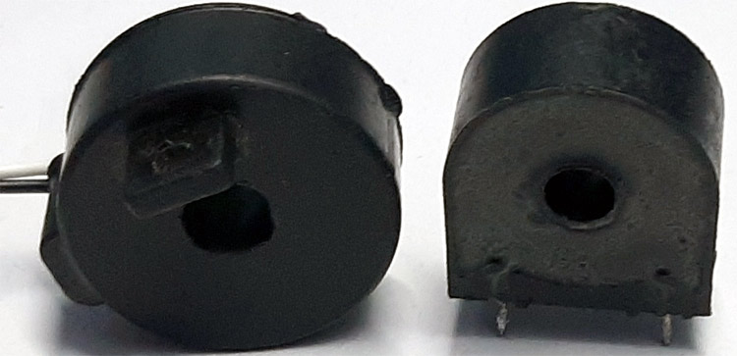**

As I have previously mentioned, a current transformer is a transformer designed to measure current. The above showing two transformers that I currently have is called a **window-type current transformer** or commonly known as a**core-balance transforme**r.

**How Current Transformer Works?**

The basic principle of the current transformer is the same as a voltage transformer, alike voltage transformer the current transformer also consists of a primary winding and a secondary winding. When an alternating electric current passes through the transformer's primary winding, alternating magnetic flux is produced, which induces an alternating current in the secondary winding at this point you can say its almost the same as a voltage transformer if you are thinking this here is the difference.

Generally, a current transformer is always in a short circuit condition with the assistance of a **burden resistor**,also, the current flowing on the secondary winding only depends on the primary current flowing through the conductor.

**Current Transformer Construction**

**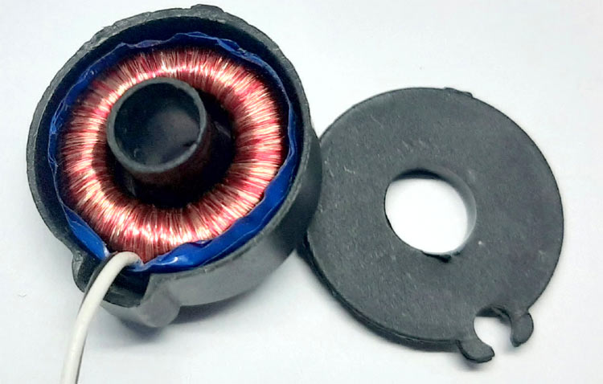**

To give you a better understanding, I have torn down one of my current transformers which you can see in the above image.

It can be seen in the image that a very thin wire is wounded around a toroidal core material, and a set of wires are coming out of the transformer. The prime winding is only a single wire which is connected in series with the load and carries the bulk current flowing through the load.

**Current Transformer Ratio**

**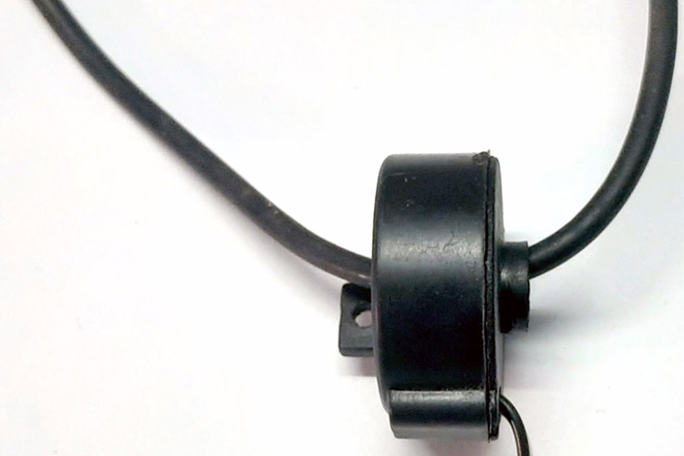**

By placing a wire inside the window of the current transformer, we can form a single loop and the **turns ratio** becomes 1:N.

Like any other transformer, a current transformer must satisfy the amp-turn ratio equation which is shown below.

**TR = Np / Ns = Is / Ip**

Where,

TR =Trans Ratio

Np = Number of primary Turns

Ns = Number of Secondary Turns

Ip = Current in primary Winding

Is = Current in Secondary Winding

To find the secondary current, rearrange the equation to

**Is = Ip x (Np/NS)**

As you can see in the above image, the primary winding of the transformer consists of one winding and the secondary winding of the transformer consists of thousands of windings if we assume 100A of current is flowing through the primary winding, the secondary current will be 5A. So, the ratio between primary to secondary becomes 100A to 5A or 20:1. So, it can be said that the primary current is 20 times higher than that of secondary current.

**Note! Please note that the current ratio is not the same as the turns ratio.**

Now all the basic theory out of the way, we can turn our focus back to calculating the turns ratio of the current transformer in hand.

**Current Transformer Error**

Every circuit has some errors. Current transformers are no different; there exist various errors in a current transformer. Some of which are described below

**Ratio Error in Current Transformer**

The primary current of the current transformer is not exactly equal to the secondary current multiplied by the turns ratio. A portion of the current is consumed by the core of the transformer to get it to an excitation state.

**Phase Angle Error in Current Transformer**

For an ideal CT, the primary and secondary current vector is zero. But in an actual Current Transformer, there will always be a difference because the primary has to supply the excitation current to the core and there will be a small phase difference.

**How to Reduce Error in a Current Transformer?**

It's always necessary to reduce errors in a system to achieve better performance. So, by below steps, one can achieve that

1. Using a core with a high permeability with a low hysteresis magnetic material.
2. The burden resistor value must be very close to the calculated value.
3. The internal impedance of the secondary can be lowered.

**Back Calculating the Turns Ratio of a Current Transformer​**

**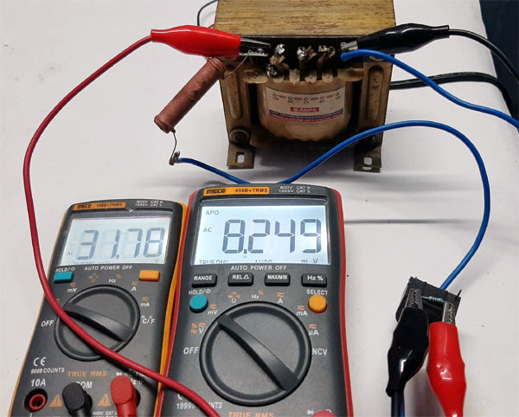**

The test setup has been shown in the above image which I have used to figure out the turns ratio.

As I have mentioned before, the Current Transformer (CT) I own does not have any specification or part number just because I salvaged them from a broken household electric meter. So, at this point, we need to know the turns ratio to set the value of the **Burden Resistor** properly, otherwise, all sorts of issues will be introduced in the system, which I will talk more about later in the article.

With the help of the [ohm's law](https://circuitdigest.com/calculators/ohms-law-calculator), the turns ratio can be easily figured out but before that, I need to measure the big 10W, 1K resistor which is acting as a load in the circuit, and I also need to get an **arbitrary burden resistor** to figure out the turns ratio.

**The Load Resistor**

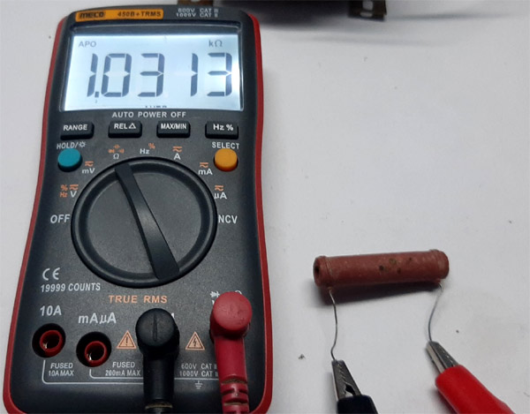

**The Burden Resistor**

**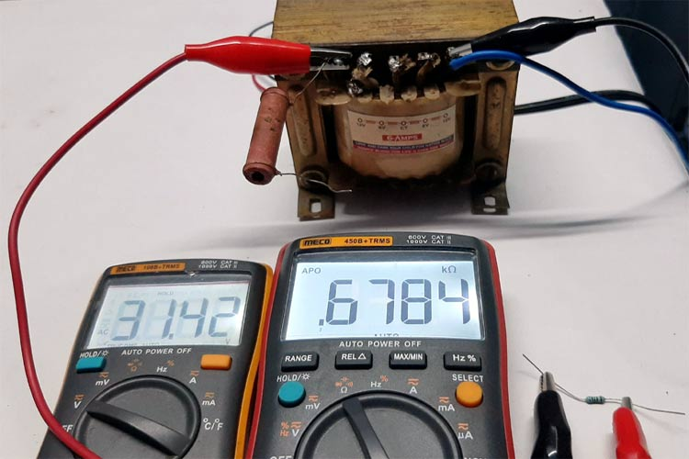**

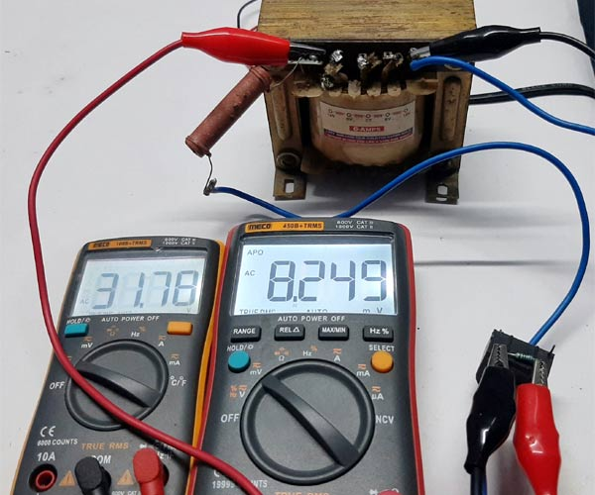

Summary of all the component values during the time of testing

Input Voltage **Vin = 31.78 V**

Load Resistance**RL = 1.0313 KΩ**

Burden Resistance **RB = 678.4 Ω**

Output Voltage **Vout = 8.249 mV or 0.008249 V**

The current flowing through the load resistor is

**I = Vin / RL**

**I =** **31.78 / 1.0313 = 0.03080A or 30.80 mA**

So now we know the **input current,** which is **0.03080A or 30.80 mA**

Let's find out the **output current**

**I = Vout / RB**

**I = 0.008249 / 678.4 = 0.00001215949A or 12.1594 uA**

Now, to **calculate the turns ratio,** we need to divide the primary current with the secondary current.

**Turns Ratio n = Primary Current / Secondary current**

**n = 0.03080 / 0.0000121594 = 2,533.1972**

So the Current Transformer consists of **2500 turns (round off value)**

**Note! Please note the errors are mostly due to my ever-changing input voltage and multimeter tolerance.**

**Calculating a Suitable Burden Resistor Size**

The CT used here is a **current output type.**So to measure current, it needs to be converted into a voltage type. This article, in the [openenergymonitor](https://openenergymonitor.org/forum-archive/node/156.html" \t "_blank) website, gives a great idea about how we can do that so I am going to follow the article

**Burden Resistor (ohms) = (AREF \* CT TURNS) / (2√2 \* max primary current)**

Where,

AREF = Analog reference voltage of the ADS1115 module which is set to 4.096V.

CT TURNS = No. of secondary turns, which we have previously calculated.

Max Primary Current = maximum primary current, which will be flown through the CT.

**Note! Every CT has a Maximum current rating exceeding that rating will lead to core saturation and ultimately linearity errors which will lead to measurement error**

**Note! The maximum current rating of the household energy meter is 30A, so I am going for that value.**

**Burden Resistor (ohms) = (4.096 \* 2500) / (2√2 \* 30) = 120.6 Ω**

120.6Ω is not a common value, that is why I am going to use three resistors in series to get 120Ω resistor-value. After connecting the resistors to the CT, I did some tests to calculate the maximum output voltage from the CT.

After the test, it is observed that if **1mA current**is fed through the primary of the current transformer, the output was **0.0488mV RMS.** With that, we can calculate if 30A current is flown through the CT the output voltage will be**30000 \* 0.0488 = 1.465V.**

Now, with the calculations done, I have set **ADC** **gain** to **1x gain** which is **+/- 4.096V,**which gives us 0.125mV full-scale resolution. With that, we will be able to calculate the minimum current that can be measured with this setup. Which turned out to be **3mA b**ecause the ADC resolution was set to 0.125mV.

**Components Required**

Write all the component without table

|  |  |  |  |
| --- | --- | --- | --- |
| **Sl.No** | **Parts** | **Type** | **Quantity** |
| 1 | CT | Window Type | 1 |
| 2 | Arduino Nano | Generic | 1 |
| 3 | AD736 | IC | 1 |
| 4 | ADS1115 | 16-Bit ADC | 1 |
| 5 | LMC7660 | IC | 1 |
| 6 | 120Ω, 1% | Resistor | 1 |
| 7 | 10uF | Capacitor | 2 |
| 8 | 33uF | Capacitor | 1 |
| 9 | Breadboard | Generic | 1 |
| 10 | Jumper Wires | Generic | 10 |

**Circuit Diagram**

The below schematic shows the hookup guide for **current measurement using the current transformer**

[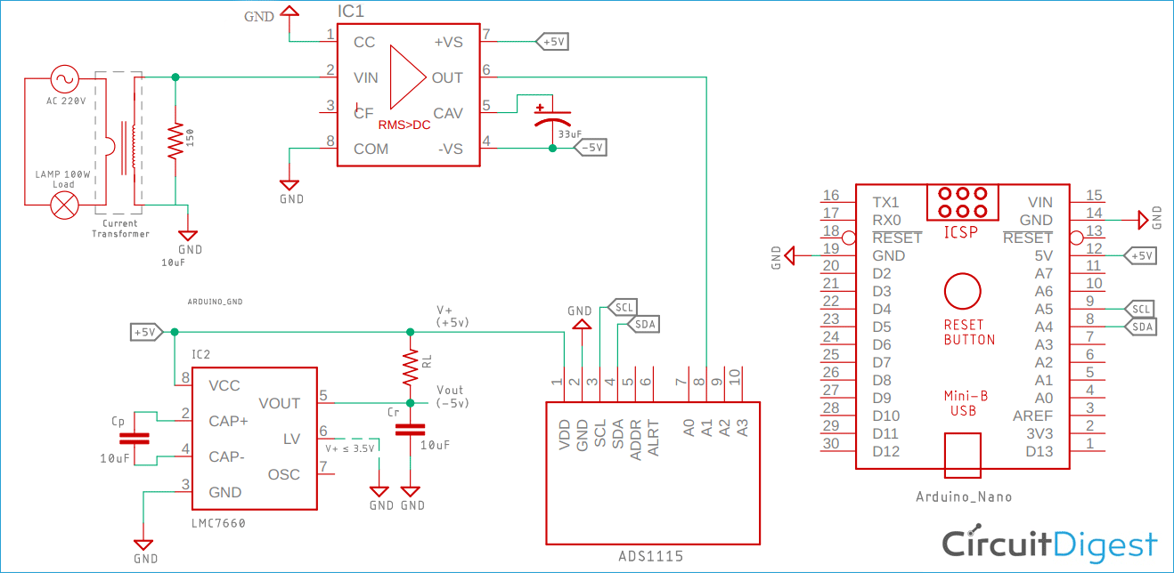](https://circuitdigest.com/fullimage?i=circuitdiagram/Current-Measurement-Circuit-Diagram.png)

This is how the circuit will look on the breadboard.

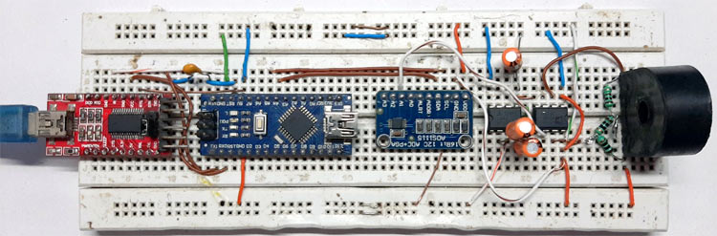

**Current Measurement Circuit Construction**

In a previous tutorial, I have shown you how to accurately measure [True RMS voltage with the help of AD736 IC](https://circuitdigest.com/tutorial/true-rms-to-dc-converter-using-ad736-ic) and how to configure a [switched capacitor voltage converter circuit](https://circuitdigest.com/electronic-circuits/switched-capacitor-voltage-converter) that generates a negative voltage from an input positive voltage, in this tutorial, we are using both the ICs from these tutorials.

For this demonstration, the circuit is constructed on a solderless Breadboard, with the help of the schematic; also, the DC voltage is measured with the help of a 16bit ADC for better accuracy. And as I am demonstrating the circuit on a breadboard to reduce the parasitic, I have used as many jumper cables as possible.

**Arduino Code for Current Measurement**

Here Arduino is used to displaying the measured values to the serial monitor window. But with a little modification in the code, one can very easily display the values on 16x2 LCD. Learn the [interfacing of 16x2 LCD with Arduino](https://circuitdigest.com/microcontroller-projects/arduino-lcd-interfacing-tutorial) here.

Complete code for the **current transformer** can be found at the end of this section. Here important parts of the program are explained.

We start by including all the required libraries files. The Wire library is used to communicate between the Arduino and the ADS1115 module and the [Adafruit\_ADS1015](https://github.com/adafruit/Adafruit_ADS1X15) library helps us to read data and write instructions to the module.

#include <Wire.h>

#include <Adafruit\_ADS1015.h>

Next, define the ***MULTIPLICATION\_FACTOR*** which is used to calculate the current value from the ADC value.

#define MULTIPLICATION\_FACTOR 0.002734 /\* factor to calculate actual current value \*/

Adafruit\_ADS1115 ads; /\* Use this for the 16-bit version ADS1115 \*/

The 16-bit ADC spits outs 16-bit long integers so the *int16\_t* variable is used. Three other variables are used, one to store the RAW value for the ADC, one to display the actual voltage in the ADC pin and finally one to display this voltage value to current value.

int16\_t adc1\_raw\_value; /\* variable to store raw ADC value\*/

float measured\_voltae; /\* variable to store measured voltage\*/

float current; /\* variable to store calculated current\*/

Begin the setup section of the code by enabling the serial output with 9600 baud. Then print the gain of the ADC which is set; this is because voltage more than the defined value can certainly damage the device.

Now set the ADC gain with the **ads.setGain(GAIN\_ONE);** the method which sets the 1-bit resolution to  **0.125mV**

After that, the ADC *begin* method is called which sets everything up in the hardware module and stats conversion.

void setup(void)

{

Serial.begin(9600);

Serial.println("Getting single-ended readings from AIN0..3"); //some debug information

Serial.println("ADC Range: +/- 4.096V (1 bit = 2mV/ADS1015, 0.125mV/ADS1115)");

// The ADC input range (or gain) can be changed via the following

// functions, but be careful never to exceed VDD +0.3V max, or to

// exceed the upper and lower limits if you adjust the input range!

// Setting these values incorrectly may destroy your ADC!

// ADS1015 ADS1115

// ------- -------

// ads.setGain(GAIN\_TWOTHIRDS); // 2/3x gain +/- 6.144V 1 bit = 3mV 0.1875mV (default)

ads.setGain(GAIN\_ONE); // 1x gain +/- 4.096V 1 bit = 2mV 0.125mV

//ads.setGain(GAIN\_TWO); // 2x gain +/- 2.048V 1 bit = 1mV 0.0625mV

// ads.setGain(GAIN\_FOUR); // 4x gain +/- 1.024V 1 bit = 0.5mV 0.03125mV

// ads.setGain(GAIN\_EIGHT); // 8x gain +/- 0.512V 1 bit = 0.25mV 0.015625mV

// ads.setGain(GAIN\_SIXTEEN); // 16x gain +/- 0.256V 1 bit = 0.125mV 0.0078125mV

ads.begin();

}

In the *loop*section, I read the raw ADC value and store it to the previously mentioned variable for later use. Then convert the raw ADC value to voltage values for measurement and calculate the current value and display it to the serial monitor window.

void loop(void)

{

adc1\_raw\_value = ads.readADC\_SingleEnded(1);

measured\_voltae = adc1\_raw\_value \* (4.096 / 32768);

current = adc1\_raw\_value \* MULTIPLICATION\_FACTOR;

Serial.print("ADC Value: "); Serial.println(adc1\_raw\_value);

Serial.print("Measured Voltage: "); Serial.println(measured\_voltae);Serial.println("V");

Serial.print("Calculated Current: "); Serial.print(val,5); Serial.println("A");

Serial.println(" ");

delay(500);

}

**Note! If you do not have the library for the ADS1115 module, you need to include the library in the Arduino IDE, you can find the library in this [GitHub repository](https://github.com/adafruit/Adafruit_ADS1X15" \t "_blank)**.

Complete Arduino code is given below:

#include <Wire.h>

#include <Adafruit\_ADS1015.h>

#define MULTIPLICATION\_FACTOR 0.002734 /\* factor to calculate actual current value \*/

#define ADC\_MAX\_VALUE 32768 /\* maximum value that ADC produces\*/

#define ADC\_GAIN 4.096

Adafruit\_ADS1115 ads; /\* Use this for the 16-bit version ADS1115 \*/

int16\_t adc1\_raw\_value; /\* variable to store raw ADC value\*/

float measured\_voltae; /\* variable to store measured voltae\*/

float current; /\* variable to store calculated current\*/

void setup(void)

{

Serial.begin(9600);

Serial.println("Getting single-ended readings from AIN0..3"); //some debug information

Serial.println("ADC Range: +/- 4.096V (1 bit = 2mV/ADS1015, 0.125mV/ADS1115)");

// The ADC input range (or gain) can be changed via the following

// functions, but be careful never to exceed VDD +0.3V max, or to

// exceed the upper and lower limits if you adjust the input range!

// Setting these values incorrectly may destroy your ADC!

// ADS1015 ADS1115

// ------- -------

// ads.setGain(GAIN\_TWOTHIRDS); // 2/3x gain +/- 6.144V 1 bit = 3mV 0.1875mV (default)

ads.setGain(GAIN\_ONE); // 1x gain +/- 4.096V 1 bit = 2mV 0.125mV

//ads.setGain(GAIN\_TWO); // 2x gain +/- 2.048V 1 bit = 1mV 0.0625mV

// ads.setGain(GAIN\_FOUR); // 4x gain +/- 1.024V 1 bit = 0.5mV 0.03125mV

// ads.setGain(GAIN\_EIGHT); // 8x gain +/- 0.512V 1 bit = 0.25mV 0.015625mV

// ads.setGain(GAIN\_SIXTEEN); // 16x gain +/- 0.256V 1 bit = 0.125mV 0.0078125mV

ads.begin();

}

void loop(void)

{

adc1\_raw\_value = ads.readADC\_SingleEnded(1);

measured\_voltae = adc1\_raw\_value \* (ADC\_GAIN / ADC\_MAX\_VALUE);

current = adc1\_raw\_value \* MULTIPLICATION\_FACTOR;

Serial.print("ADC Value: "); Serial.println(adc1\_raw\_value);

Serial.print("Measured Voltage: "); Serial.print(measured\_voltae);Serial.println("V");

Serial.print("Calculated Current: "); Serial.print(current,5); Serial.println("A");

Serial.println(" ");

delay(500);

}

**Testing the Circuit**

**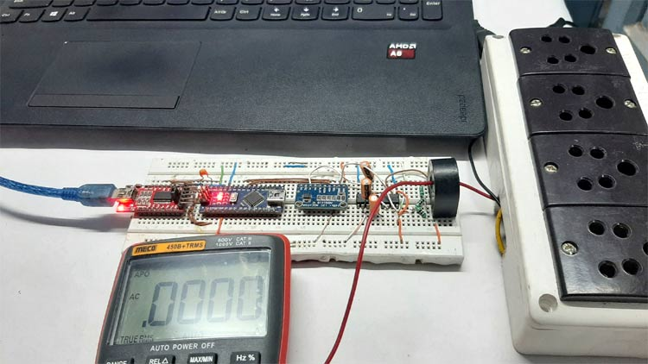**

Tools used to test the circuit

1. 2 60W incandescent light bulb
2. Meco 450B+TRMS Multimeter

To test the circuit the above setup was used. The current is flowing from the CT to the multimeter, then it is going back to the main's power line.

If you are wondering what an FTDI board is doing in this setup, let me tell you that the onboard USB to serial converter was not working, so I had to use an FTDI converter as a USB to serial converter.